

Proposal for issue of stingray fishing licenses in Malaysian waters

(for the period of oct 2017 to SEP 2027)





Table of Contents

Executive Summary 3

1 Objective 4

2 Background 4

2.1 Overview 4

2.2 Initial conditions and parameters 5

2.2.1 Determination of parameter r 5

2.2.2 Determination of parameter k 8

2.2.3 Determination of parameter m 10

2.2.4 Determination of parameter N 12

3 Numerical method and implementation 14

3.1 Overview 14

3.1.1 Discussion of time-step 14

3.2 Euler Explicit method 15

3.2.1 Description 15

3.2.2 Matlab subroutine 15

3.2.3 Results 15

3.3 Trapezoidal method 18

3.3.1 Description 18

3.3.2 Matlab subroutine 18

3.3.3 Results 18

3.4 Modified Trapezoidal method 20

3.4.1 Description 20

3.4.2 Matlab subroutine 20

3.4.3 Results 20

3.5 Runge-Kutta (RK 4) 23

3.5.1 Description 23

3.5.2 Matlab subroutine 23

3.5.3 Results 23

3.6 Ranking of methods 26

4 Stability Analysis 27

4.1 Definition of Stability 27

4.1.1 Stability and Critical Time Step, hcritical 27

4.1.2 Stability analysis of non-linear function. 27

4.2 Linearization of population dynamic equation 28

4.3 Range of stability for Euler Explicit 29

4.4 Range of stability for Trapezoidal method 31

4.5 Range of stability for Modified Trapezoidal method 33

4.6 Range of stability for RK4 35

4.7 Summary of Stability 37

5 Accuracy Analysis 38

6 Conclusion 40

7 References 40

Appendix 42

General 42

Euler Explicit method (Subroutine) 42

Trapezoidal method (Subroutine) 43

Modified Trapezoidal method (Subroutine) 44

RK4 method (Subroutine) 44

# Executive Summary

This report presents the findings from the analysis conducted by Team B, in response to a project tender request, ID53772017B, by Fisheries Development Authority of Malaysia (FDAM).

The objective of the report is to find the optimum number of fishing licenses to be issued for the period of 1st October 2017 to 30th September 2027, in order to maintain the population of stingrays above the 1.5 times of minimum population threshold.

The analysis concludes that the numerical method Runge-Kutta (RK4) obtains the best estimate for the solution, considering the stability and accuracy of the method. The other methods considered are Euler Explicit, Trapezoidal and Modified Trapezoidal method.

The recommended number of fishing licenses to be issued is 10.

|  |  |  |
| --- | --- | --- |
| Endorsed by: | Project Manager | Ng Wen Hao |
| Approved by: | Technical Director | Dennis Ong |
| Reviewed by: | Business Development Manager | Li Zhi |
| Reviewed by: | Industry Relations Manager | Chen Ying Xuan |
| Reviewed by: | Environmental Consultant | Cherie Aw |

# Objective

This proposal is drafted as a recommendation to the Fisheries Development Authority of Malaysia (FDAM), a statutory board under the Ministry of Agriculture & Agro-based Industry Malaysia, on the number of stingray fishing licenses to be issued for the period stated between 1st October 2017 to 30th September 2027.

The document will provide detailed discussion and analysis on the determination of the existing parameters affecting the population dynamics and the selection of a suitable numerical method to be applied to determine the number of licenses, N to be issued.

# Background

## Overview

The population dynamics of stingrays in Malaysian waters can be described by the following equation:

where P is population measured in thousand tons

t is the number of years

r is the growth rate of stingrays

k is the population capacity of stingrays

m is the minimum threshold value

N is the number of stingray fishing licenses to be issued

This equation is non-linear, non-homogenous and is a first-order ordinary differential equation (ODE).

## Initial conditions and parameters

The stingray population, P0 as of September 2017, is estimated to be at 30 thousand tons.

The number of stingray fishing licenses to be issued by FDAM is based on the requirement that the population of stingray is maintained at greater than 1.5 times the minimum threshold value (P≥) at all times over the next 10 years (2017 to 2027). With consideration of the parameters and conditions to be utilized in the modelling process, as summarized in Table 1, the minimum population required, P is calculated to be 19.5 thousand tons.

Table : Summary of defined parameters and values

|  |  |  |  |
| --- | --- | --- | --- |
| **Parameter** | **Value (Existing expectation)** | **Values**  **(10 years ago)** | **Unit** |
| Initial population, P0 | 30 | - | thousand tons |
| Time, t | 0 | - | year |
| Growth rate, r | 3 | 4 | thousand tons per year |
| Population capacity, k | 38 | 55 | thousand tons |
| Minimum threshold, m | 13 | 10 | thousand tons |

The following sections will elaborate on the parameter values chosen, supplemented with numerical modelling results and evidence from sources. Trapezoidal method, which is unconditionally stable, is utilized to initialize the parameters.

### Determination of parameter r

The parameter r refers to the growth rate of the stingray population, which is directly related to the reproduction rate of stingrays. It can be reasoned that there had been a decrease in r value from that adopted 10 years ago (i.e. 4) because of the following reasons:

1. Stingray can only mate when there is adequate habitat and food to support their survival (BioExpedition, 2012). Due to the reclamation projects in Malaysia, such as in Penang, Melaka and Johor, hundreds of hectares of marine and coastal habitats have disappeared (Idris, 2017). The mining of marine sand and aggregates for reclamation has also affected the ecosystem, especially in the benthic zone (Idris, 2017), which provides the main source of food for the stingrays. Thus, this reduction in habitat space and availability of food will cause a decrease in reproduction rate of stingrays and consequently a decrease in their growth rate.
2. There is an optimum water temperature for reproduction for each species of stingray (Spells, n.d.). If the water temperature is higher or lower than optimum, it would negatively affect the reproduction rate. Due to global warming, sea temperature has been on the rise (National Geographic, 2010) and this would cause a decrease in reproduction rate of stingrays.

Though it has been observed that growth rate decreased during the past 10 years, it is difficult to quantify the extent of decline, because of limited available survey data of estimated numbers of stingrays over the past 10 years. The growth rate is projected to decrease gradually and hence *r value of 3* is adopted for this proposal, which is a 25% decrease from the value 10 years ago.

This projection is supported by the numerical analysis of the population, based on different r values from 1 to 4, for the next 10 years. For these simulations, the value of N is fixed at 10 and value of m is fixed at 10, which is the value from 10 years ago. The value of k varies from 25 to 55 because k is postulated to have decreased in the past 10 years (detailed in section 2.2.2). It can be seen from the graphs that as r decreases, the range of k that will not result in the population dying out in 10 years becomes smaller. Thus, it is not reasonable to choose a value of r that is too small. This is because the population will die out easily even with a small decrease in value of k, which is not logical.

For a brief summary of the ranges in Figure 1, Figure 2, Figure 3 and Figure 4, where population stays sustainable, when r=4, k ranges from 27 to 55; when r=3, k ranges from 30 to 55; when r=2, k ranges from 34 to 55; when r=1, k ranges from 45 to 55.

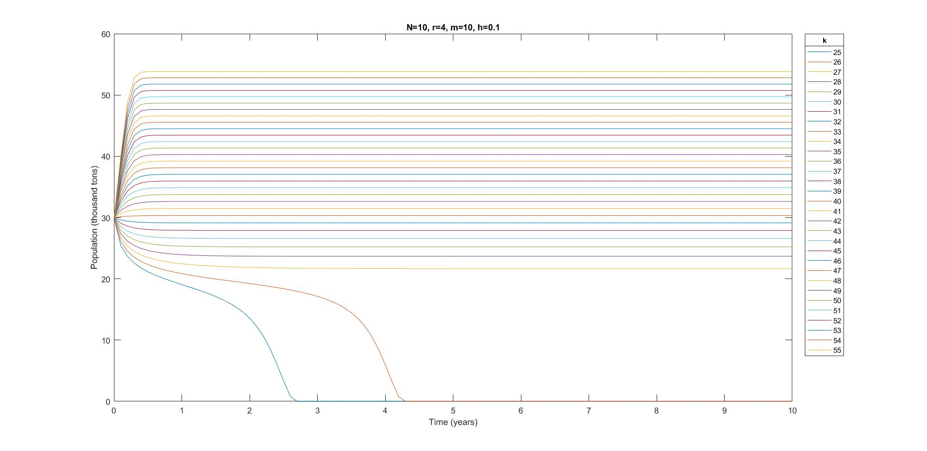

Figure : Graph of population when r=4

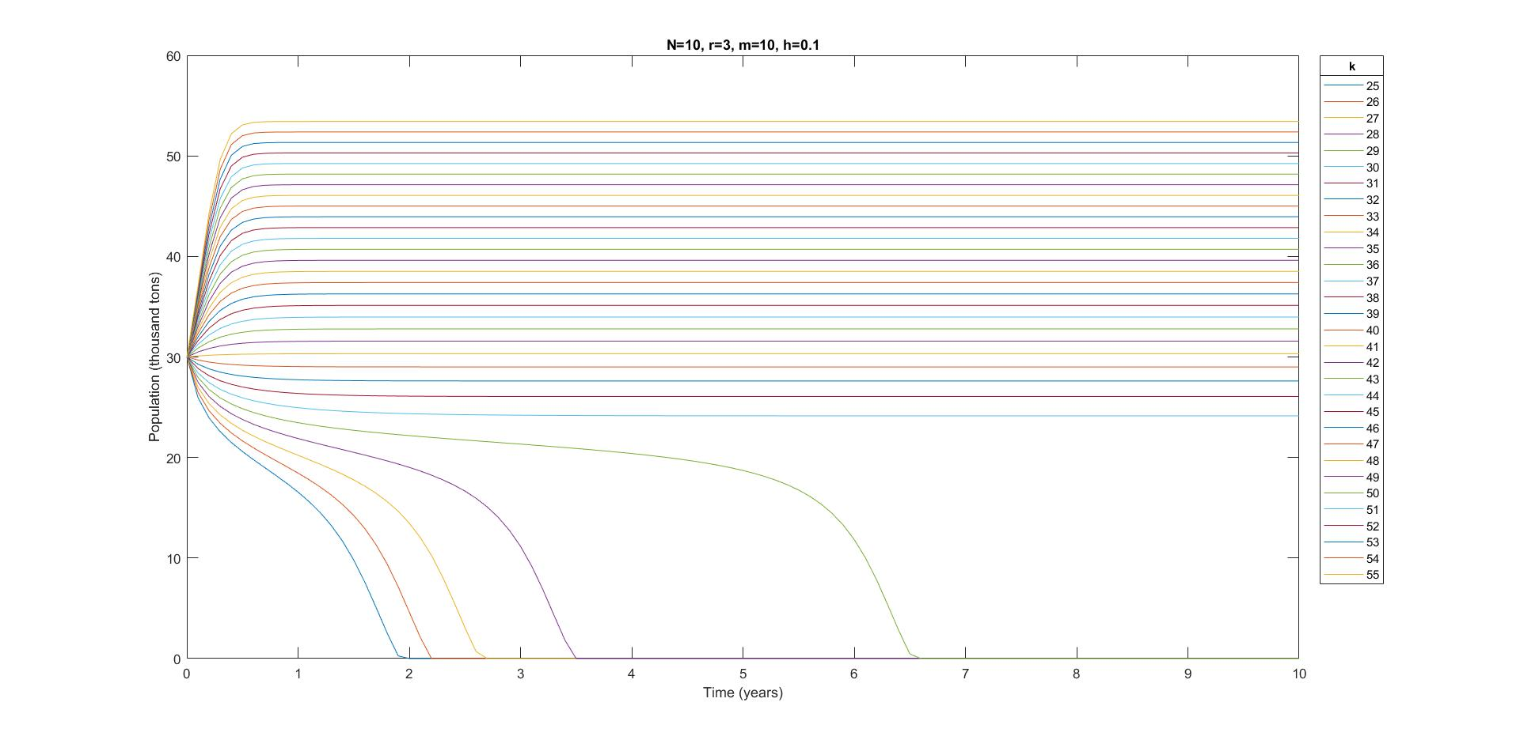

Figure : Graph of population when r=3

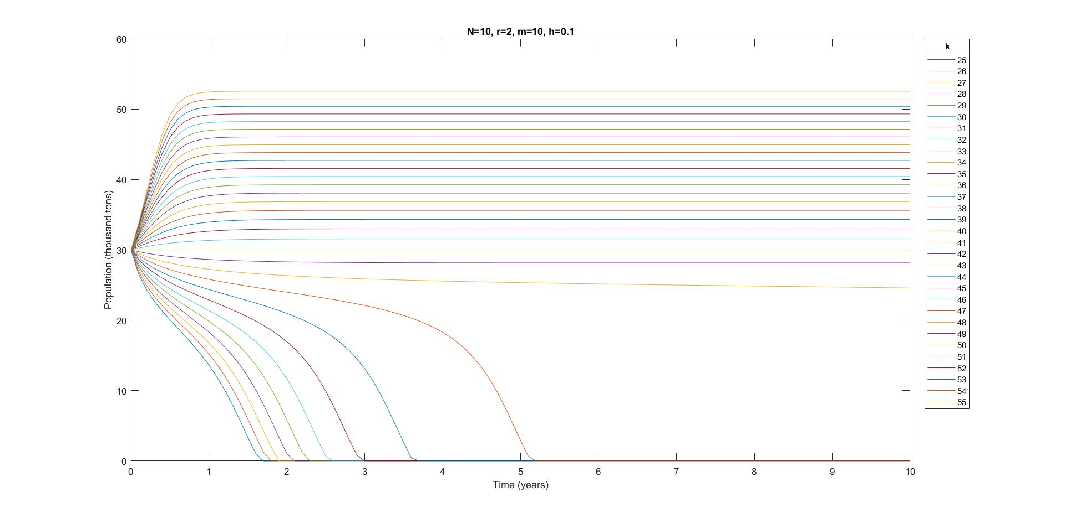

Figure : Graph of population when r=2

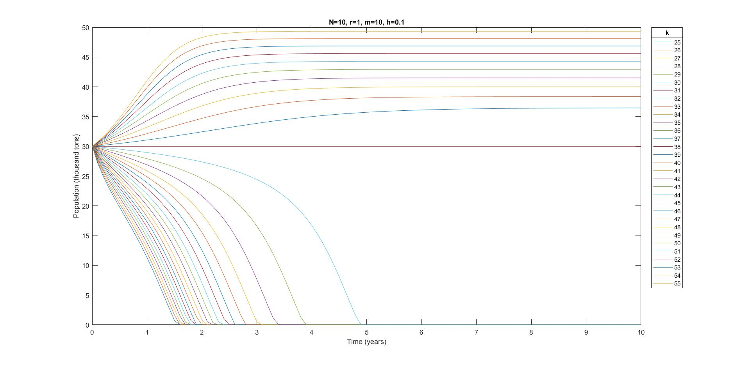

Figure : Graph of population when r=1

### Determination of parameter k

The parameter k refers to the population capacity of stingrays. The population capacity of a species is defined as the maximum population size of the species that the environment can sustain indefinitely, on the condition that resources essential for the survival of the species are adequately available, e.g. food, habitat. The rationale for choosing a lower k value as compared to that adopted 10 years ago (i.e. 55) are presented in the following points, increased shipping activities and marine pollution.

1. Increased shipping activities in the Malaysian waters over the past 10 years has resulted in disturbance to the marine habitat. The discharge of ballast water, which is used to maintain the ship’s stability, creates a risk of invasive non-native species being introduced into the aquatic environment (Mobilik & Hassan, 2016). Without natural predators available, there is a high possibility of certain invasive species being able to thrive and eventually affect the delicate ecological balance in the sensitive coastal ecosystem. This results in higher competition with native species for food and space, thus disrupting the existing marine food web. In other words, there is a risk of depletion of resources required for the stingray to thrive in the next 10 years. In addition, the increasing shipping activities in Malaysian waters had affected the movement and feeding patterns of the marine species, forcing them to migrate to quieter waters, which may not present the best conditions for survival of the stingray population.
2. Marine pollution has steadily increased over the years. Between 2009 and 2015, a total of 121 cases of oil pollution had been reported, which are either deliberately discharged or spilled as a result of vessel collisions (Alam, 2016). Areas affected by such oil pollution included coastal regions in Terengganu and Pahang. Such incidents caused a great reduction in food and habitat space for the marine species. Moreover, the marine habitat requires time to recover from marine pollution, which on the contrary are happening at a higher frequency as a result of greater volume of coastal and shipping activities.

Taking into account for the possible shrinkages in food resources and habitat space for stingrays in the near future, *a conservative value of k=38* is chosen for the population capacity, k. The value is obtained based on the prediction of shipping activities to increase by a further 30% over the next 10 years with the expansion in Malaysian and Singaporean ports. There is also a proportional relationship between marine pollution and negative effect on the marine environment. To analyze the feasibility of k value as 38, Figure 5 shows the plot of a range of k values. As shown, for k=38, the population can be maintained above 30 thousand tons consistently over the next 10 years even with 10 licenses, which fulfills the minimum population requirement decided by FDAM (section 2.2).

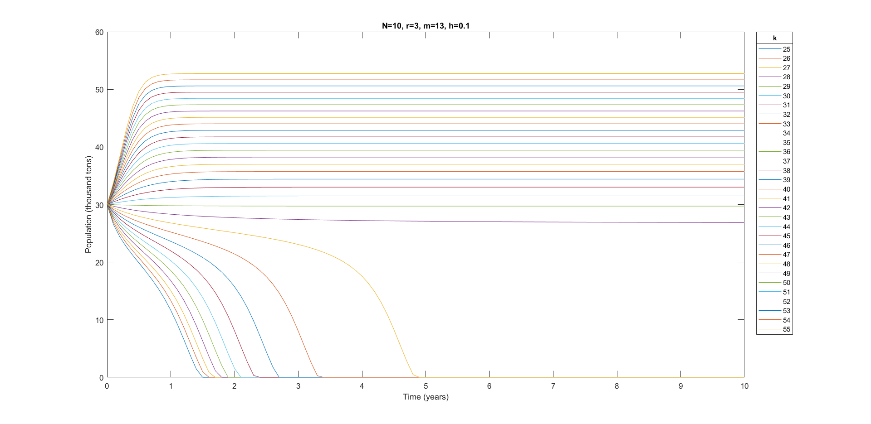

Figure : Graph of population for values of k (25 to 55)

### Determination of parameter m

The parameter m refers to the threshold population, below which the reproduction rate is less than the death rate. Consequently, the growth rate becomes negative and the population will decrease until it is wiped out. The value of m is predicted to have been required to be increased from 10 years ago to alleviate impacts from the following factors, lower reproduction rate and marine pollution.

1. As mentioned in section 2.2.1, the reproduction rate of stingrays would have decreased in the past 10 years due to destruction of their habitats and source of food, and also due to the warming of seawaters. Assuming the death rate is constant, a lower reproduction rate means that a higher minimum population is needed to maintain the same growth rate.
2. With rapid industrialization and economic development in the region, marine pollution has increased dramatically in Malaysian waters, as described in section 2.2.2. Pollutants discharged to the sea include sewage effluent, industrial discharge, runoff from land-based activities, oil spills from ships and solid waste such as plastic (Idris, 2017). One of the major concerns is emerging pollutants, such as synthetic hormones and pharmaceutical chemicals in aquatic environment, which has been detected in Malaysian waters in the past years (Al-Odaini, Pauzi Zakaria, Ismail Yaziz, & Surif, 2011). These pollutants have been reported to disrupt the endocrine system of marine organisms, possibly leading to lower rates of reproduction in stingray population (Al-Odaini & Zakaria, Management of Pharmaceutical Compounds in Environment: Occurrence, Sources, Impacts and Control, 2006).

Similar to the case of the growth rate r, the value of m should have increased in the past 10 years based on qualitative evidence but it is difficult to quantify the increase. The value of m is postulated to slightly increase in a short time span of 10 years. To understand the population trend in the next 10 years for different values of m, numerical models are run for m value from 10 to 20. The value of r is fixed at 3 and value of k is fixed at 38 as determined in the previous sections.

It is seen from the graph that the population decreases when m increases. In Figure 6, when m increases to 15 and beyond, the population will decrease and die out within 10 years. This is in-line with the postulation that m should not have increased so much from 10 years ago. Looking at Figure 7 with focus on m values from 10 to 14, it can be seen that the effect of m on the stabilized population value is amplified with each increase in m. For example, the stabilized population decreased about 0.5 thousand tons when m increased from 10 to 11, but decreased about 1.3 thousand tons when m increased from 13 to 14. The *m value of 13 is chosen,* representing a reasonable 30% increase from the value 10 years ago, but is not so drastic as to cause a wipe out of the population.

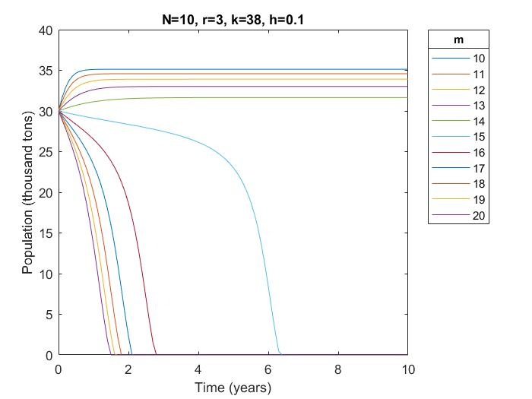

Figure : Graph of population for values of m (10 to 20)

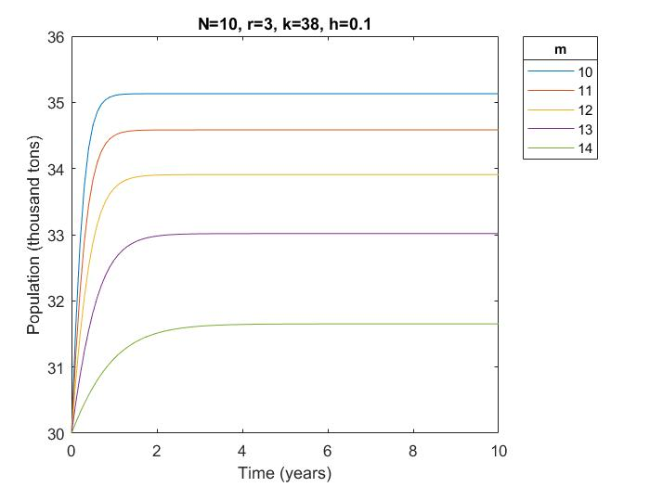

Figure : Graph of population for values of m (10 to 14)

### Determination of parameter N

The variable N denotes the number of stingray fishing licenses that FDAM issues to entities allowed to fish in Malaysian waters. Each license is entitled to catch up to two thousand tons of stingray per year. Based on the population dynamic model and the initial conditions, the optimal number of licenses to be issued is determined to be 10 licenses for the following reasons, species sustainability and marine biodiversity:

1. A report from World Wide Fund for Nature (WWF) on sustainable seafood products has listed stingrays under the list of seafood to avoid at present as they are considered to be unsustainable, overfished and over-exploited globally (World Wide Fund for Nature (WWF), 2016). The number of licenses issued between 1960 and 2016 has been maintained at more than 10 licenses per year. However, the data recorded over the years along the eastern coast of Malaysia has indicated the occurrence of overfishing in the region (Figure 8).

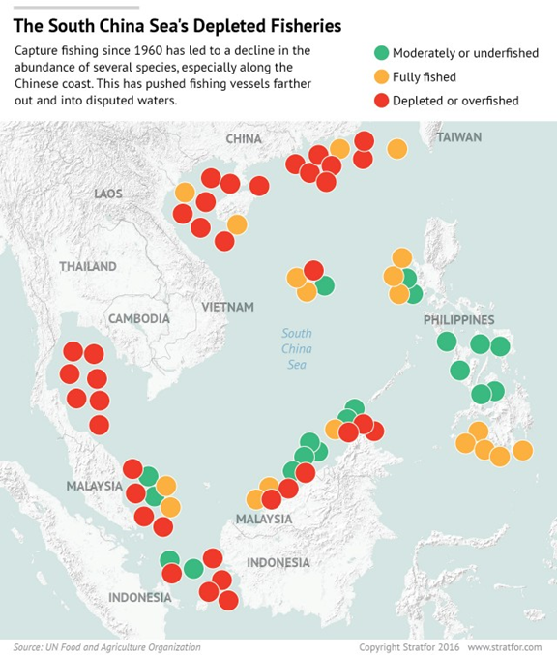

Figure : Diagram of fishing situation in the South China Sea

1. Extensive fishing for stingrays has impacted the rich marine biodiversity in the Malaysian waters, which often end up as bycatch in the nets laid out to catch stingrays along the shores (The Straits Times, 2016). One of the most affected species is the Malaysian state Terengganu’s turtle, which often ended up trapped in the nets and eventually die from drowning. From 2014 to 2016, an average of 45 deaths per year has been recorded. The actual number could be significantly higher as many deaths have gone unreported. There are concerns from the general public with regard to this bycatch issue. As much as 80% of the people population living in overfished areas are dependent on revenues brought in by tourism, tapping on the draw of pristine dive sites. Without a sustainable model for fishing, the marine biodiversity in the region is projected to plummet over the next 10 years, which affects the region’s reputation as a diving hotspot. By limiting the number of licenses, the Malaysian authorities have better control over the fishing situation in the area and safeguard the livelihoods of the people. This helps to promote adoption of more sustainable fishing practices through stricter regulations on the number of licenses issued.

With reference to Figure 9, the model predicts that for the population to maintain more than 19.5 thousand tons over the next 10 years before the population dips to extinction, the largest number of licenses allowed is 12.

As observed from the graph, the population of stingrays maintains steadily at 30 thousand tons for ≤12 licenses issued. However, it should be cautioned that once the population starts to decrease below 30 thousand tons, a steep decline will ensue. Therefore, in order to adequately safeguard the population of stingrays for the next 10 years, the number of fishing *licenses (N) recommended to be issued will be set at 10* to factor for any estimation errors in the model. In accordance with FDAM’s efforts to promote sustainable fishing practices, the reduction in licenses issued for the next 10 years will allow the stingray population to stabilize and recover from the previous years of overfishing.

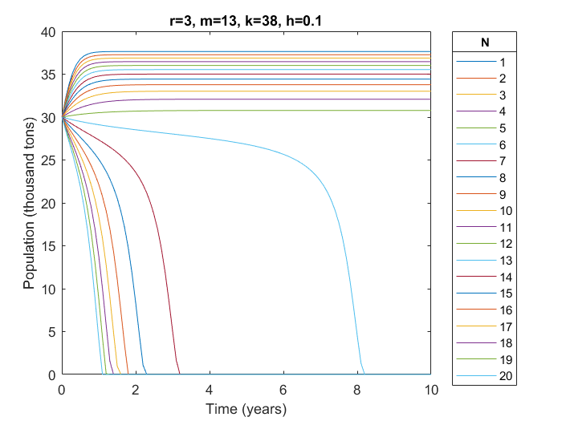

Figure : Graph of population for values of N (1 to 20)

# Numerical method and implementation

## Overview

Table 1 presents the numerical methods considered for solving the nonlinear population dynamics equation.

Table : Numerical methods used for modelling

|  |  |  |
| --- | --- | --- |
| **Method** | **Type** | **Order of accuracy** |
| Euler Explicit | Explicit | 1st order |
| Trapezoidal | Implicit | 2nd order |
| Modified Trapezoidal | Explicit | 2nd order |
| Runge-Kutta (RK4) | Explicit | 4th order |

The numerical methods are compared using stability and accuracy analysis, and *RK4 is selected as the most suitable method* to predict for the number of licenses for the next 10 years. Details of the analysis can be found in the section 3.2 to 3.6.

### Discussion of time-step

FDAM has requested for the proposal to provide data for better monitoring of the true state of fishing in the region. Team B is able to provide modelled data that allows tracking and comparison of the recorded catch on a daily basis. In order to do that, a time step of is chosen, i.e. h=0.00274.

Team B understands that each license is issued for a duration of 10 years and the fishing limit is set at two thousand tons per year. It is desirable for the population to be depleting at a reasonably gradual rate. In reality, if the physical population drops sharply within a shorter period than it is assigned to, the species may be prone to reduced growth rate r. Therefore, there is a need for measures to be in place that prevents a sharp drop in the population within a short time period.

The ability to provide model data down to the detail of a daily basis will complement FDAM’s existing implementation of physical tracking measures at the various fishery ports. This means that the modelled data can be compared with collated physical data to provide an up to date monitoring. The following measures are recommended to FDAM:

1. Random physical checks are to be conducted to ensure that reported numbers are true. Fishing boats found to be under-reporting will be mete out with severe punishments such as revoking of license for a designated time period.
2. Monthly/quarterly figures should be analyzed to ensure that there is no sharp drop in the population which can result in a short period drop in growth rate. If it is found that catching rates are faster than the allowed gradual fishing rate, alert measures can be introduced. Fishing season for rays should then be put on halt or all fishing boats should be advised to release stingray catches and switch fishing hauls.

## Euler Explicit method

### Description

Euler Explicit (EE) is a first order accurate numerical method and works by finding a solution at the next time-step , where h is the increment in time-step, using the known solution at . The method is stable provided the time-step is sufficiently small to satisfy the stability range, i.e. conditionally stable.

### Matlab subroutine

The subroutines for EE method can be found in Appendix A.

### Results

In Figure 10, the time-step with an increment of 0.1 in the range of 0.1 to 1 was used. In Figure 11, the time-step with an increment of 0.05 in the range of 0.05 to 0.5 was used. It is observed that as h decreases, the fluctuation in the solution decreases and converges towards a smooth curve. A sufficiently smooth curve is only achieved when h is 0.1. This is because EE method is only of first order accuracy and so the error is same order of magnitude as h. The population converges to stabilize at 33 thousand tons in 10 years.

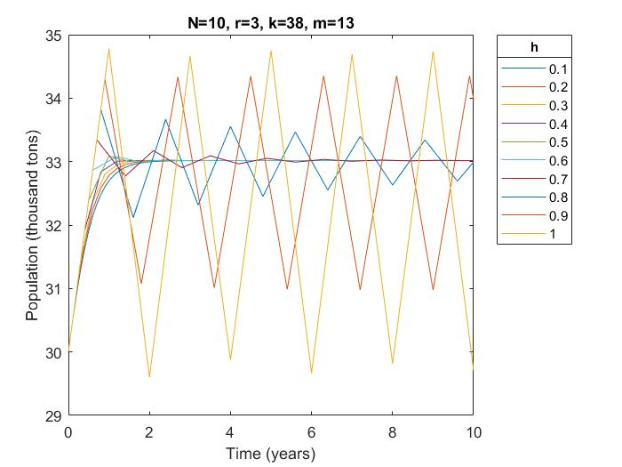

Figure : Graph of population for values of h (0.1 to 1) by EE

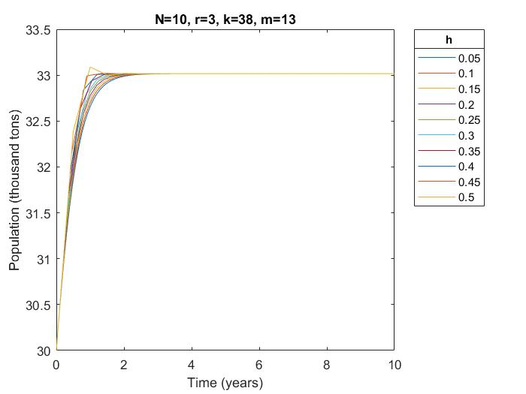

Figure : Graph of population for values of h (0.05 to 0.5) by EE

Even though the results fluctuate a lot when time-step is large (i.e. h=0.8, 0.9, 1), it does not mean that the results are not stable. Figure 12 shows the population trend for 100 years and it is seen that the fluctuation does not go unbounded for h=0.9 and 1. For h=0.8, the population does converge to the stable value though only after a very long time of 40-50 years.

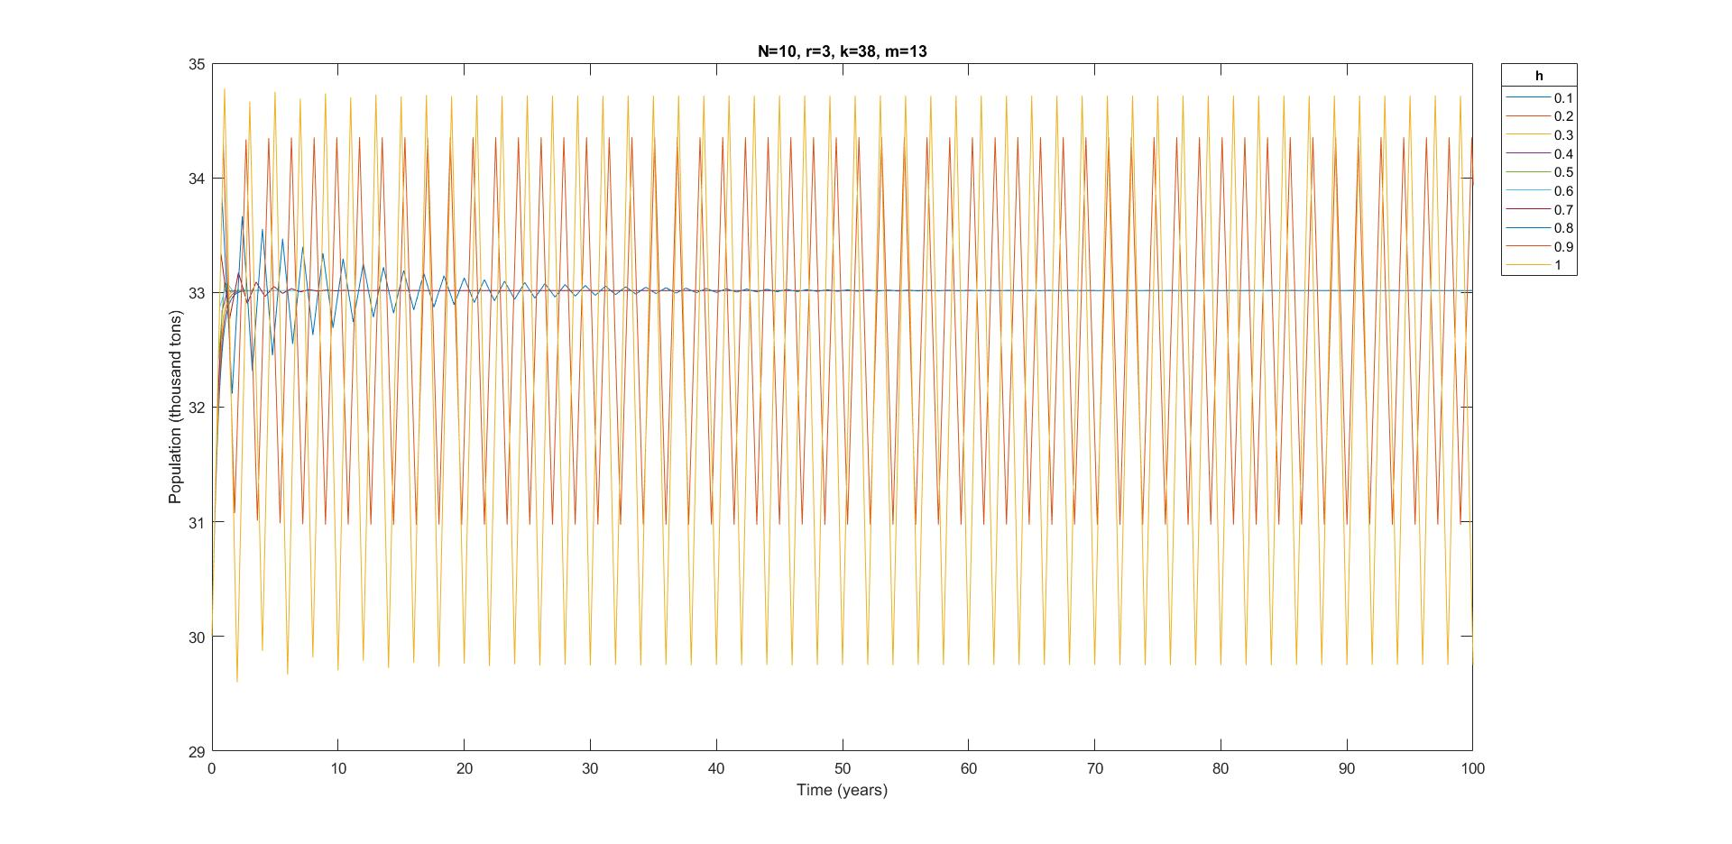

Figure : Graph of population for values of h (0.1 to 1) by EE

To find the range of h that the method becomes unstable, h values bigger than 1 are used to run the model. Figure 13 shows that the results are still stable at h=1.2 (though not accurate), but when h is increased to 1.3, the population decreases very fast and die out within 10 years. Thus, for this case, with preliminary attempts to determine the time-step duration, the Euler explicit method is found to be conditionally stable when h is smaller or equal to 1.2.

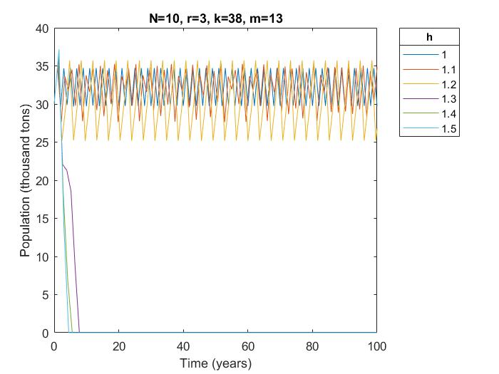

Figure : Graph of population for values of h (1 to 1.5) by EE

## Trapezoidal method

### Description

The Trapezoidal method is derived from both Euler explicit and implicit method, and it is of second order accuracy. It works by using the average of the gradient at the current time-step and the next time-step, using the formula:

Since it uses a value from the next time-step, it is an implicit method which requires a form of iteration and so may take a longer computational time. The advantage is that it is unconditionally stable regardless of the time-step chosen.

The iterations for each time-step is done using the Newton Raphson method.

### Matlab subroutine

The subroutines for the Trapezoidal-Newton Raphson (Trap-NR) method can be found in Appendix A.

### Results

Figure 14 and Figure 15 show that the fact that the Trap-NR method is unconditionally stable seems to help in the accuracy of the method as well because the results converge fast even with a relatively big time-step of 1. A time-step of 0.2 is able to produce a sufficiently smooth curve.

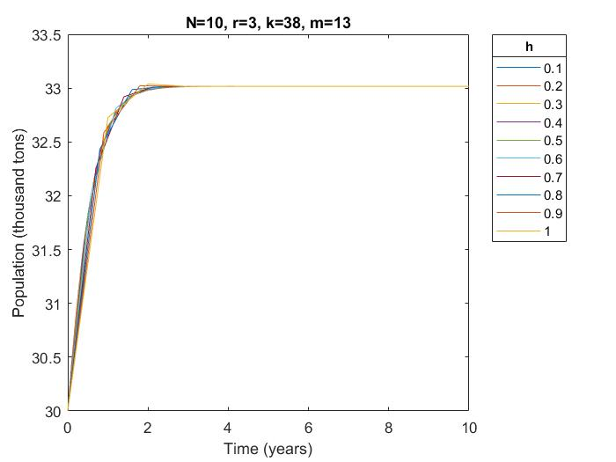

Figure : Graph of population for values of h (0.1 to 1) by Trap-NR

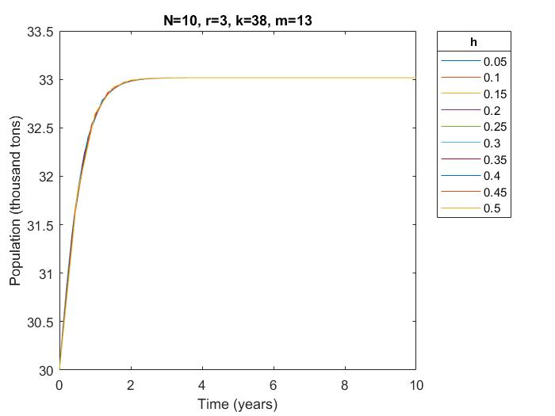

Figure : Graph of population for values of h (0.05 to 0.5) by Trap-NR

## Modified Trapezoidal method

### Description

The Modified Trapezoidal (Trap-Mod) method is derived from the implicit Trapezoidal method to become an explicit method. Thus, it is conditionally stable. Similar to the Trap-NR method, this method is of second order accuracy. The following steps are taken:

1. Use Euler explicit method to estimate an intermediate value, using the formula:

where is the gradient at the current time-step

1. Use the estimated value to approximate yi+1 using the formula:

### Matlab subroutine

The subroutines for the Trap-Mod method can be found in Appendix A.

### Results

Figure 16 and Figure 17Figure 17 show the results for the Trap-Modified method for different time-steps h. Though it does not fluctuate drastically when a big time-step is used like the EE method, it can be observed that when a big h is used, the results are not accurate. This is because the magnitude of error is proportional to h2.

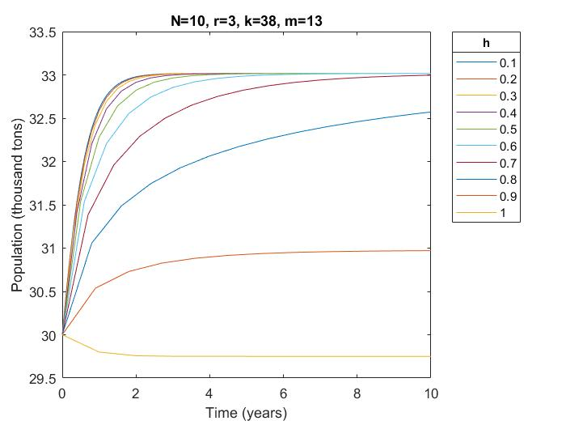

Figure : Graph of population for values of h (0.1 to 1) for trap-mod

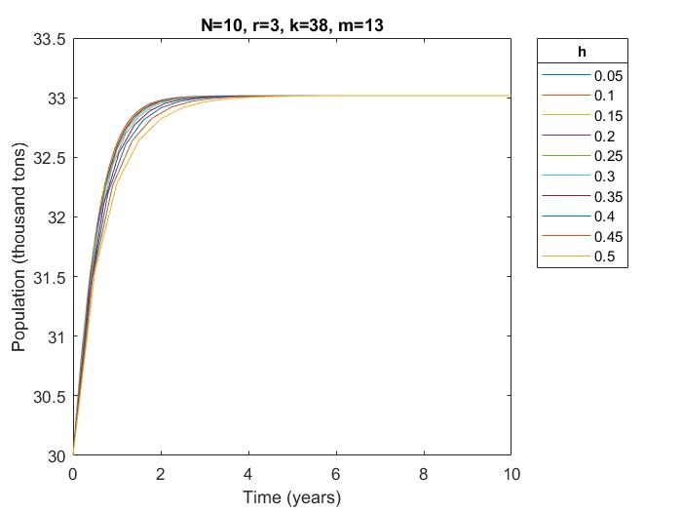

Figure : Graph of population for values of h (0.05 to 0.5) for trap-mod

Similar to the EE method, further analysis is done for a longer period of time to find the limit of h that gives a stable solution. From Figure 18, it is seen that the solution is still stable at h=1.4 but goes unbounded when h=1.5 as shown in Figure 19 . Thus, for this case, with preliminary attempts to determine the time-step duration, the maximum h for the Trap-Mod method to be stable is h=1.4.

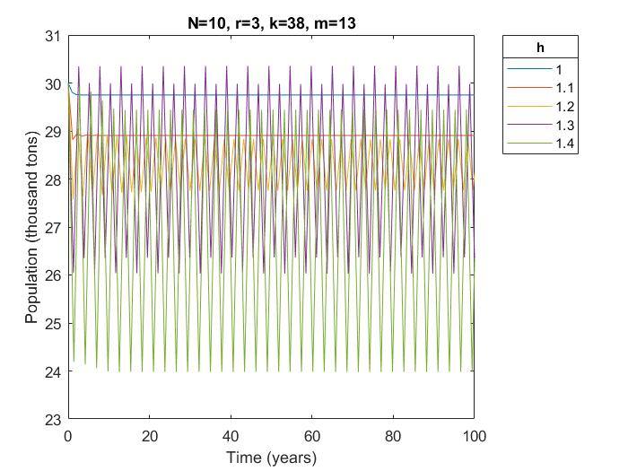

Figure : Graph of population of h (1 to 1.4) for trap-mod

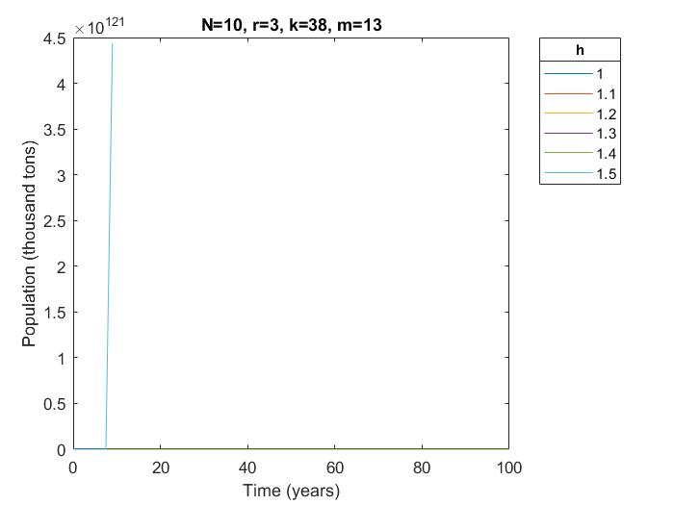

Figure : Graph of population of values of h (1 to 1.5) for trap-mod

## Runge-Kutta (RK 4)

### Description

Runge-Kutta fourth-order method (RK4) is one of the most popular predictor-corrector algorithms. RK4 method uses the following equations to solve:

1. Use Euler explicit method at half time-step to estimate an intermediate value
2. Use Euler implicit method at half time-step to estimate an intermediate value
3. Use midpoint method at a full time-step to estimate an intermediate yi+1*** value
4. Combine the estimated values obtained in parts a, b and c to compute an improved weighted-average slope

The solution computed using RK4 method will be more accurate by taking weighted-average, with estimates based on the slope at the midpoint being weighted twice as heavy as those using the slope at the end points.

### Matlab subroutine

The subroutines for RK4 method can be found in Appendix A.

### Results

Figure 20 and Figure 21 show the results using RK4 method with h values from 0.1 to 1 and from 0.05 to 0.5 respectively. It shows that the results can converge to the stable population faster than the EE and Trap-Mod method but slower than the Trap-NR method. This tallies with expectations because RK4 has higher order of accuracy than the other 2 explicit methods but is still conditionally stable unlike Trap-NR which is unconditionally stable.

Running the analysis for a longer period of 100 years, it can be seen from Figure 22 and Figure 23 that the population is still stable at h=1.72 but goes unbounded at h =1.73. Thus, for this case, with preliminary attempts to determine the time-step duration, the maximum h for the Trap-Mod method to be stable is h=1.72.

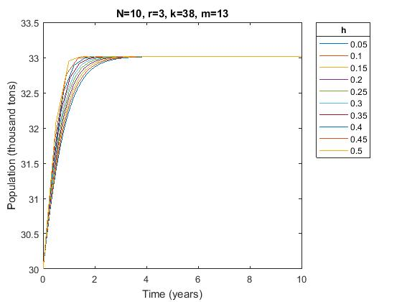

Figure : Graph of population of values of h (0.05 to 0.5) for RK4

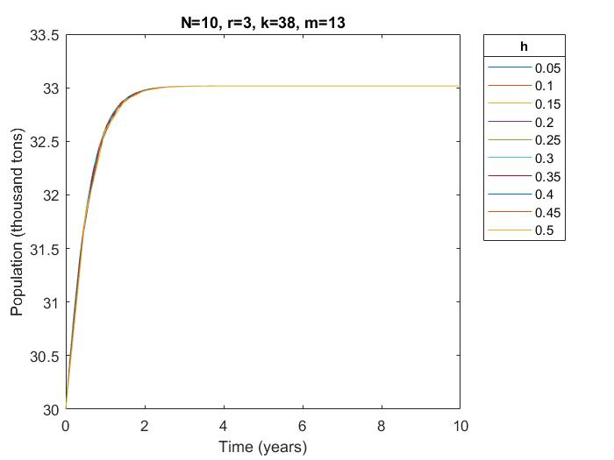

Figure : Graph of population for values of h (0.05 to 0.5) for RK4

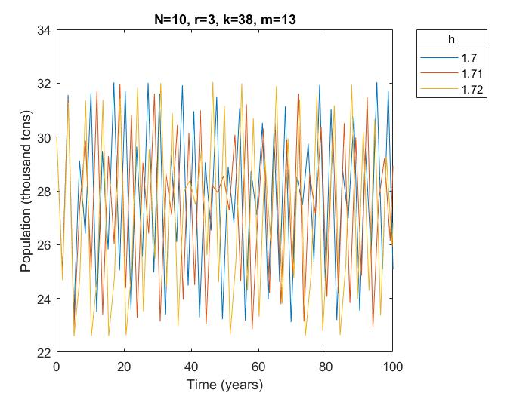

Figure : Graph of population for values of h (1.70 to 1.72) for RK4

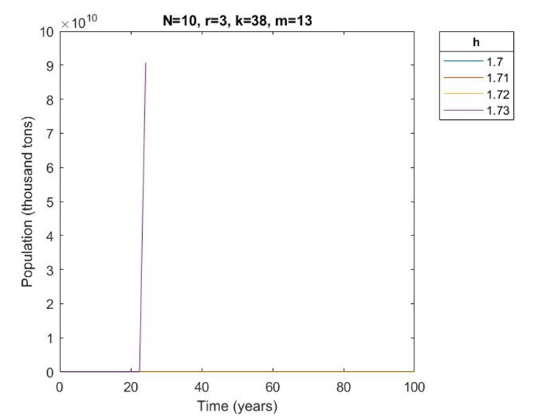

Figure : Graph of population for values of h (1.70 to 1.73) for RK4

## Ranking of methods

The various numerical methods, as discussed above, were used in the determination of the population tendency. In this section, they are ranked accordingly using the three determining factors:

1. computational time
2. number of time-step
3. stability and accuracy of method

The first factor of consideration is computational time. Computational time constitutes the time needed for the results to be run with every change of data input. It is affected by the chosen time-step duration, the number of evaluative steps and the tolerance of the iterative step.

Computational time can be affected by the time step duration that is chosen. The smaller the time step duration, the longer the computational time. Numerical methods of higher accuracies will tend towards a stable value in a shorter time duration than numerical methods with lower accuracies. In this case, RK4 allows for a bigger time step duration to reach the exact value and hence, RK4 has reduced computational time.

Another issue contributing to computational time is the number of steps in the numerical method. If the number of evaluative steps are higher, the computational time will increase. RK4 has this problem as it requires 4 sets of evaluations for every time step, as compared to the other three methods that only require 1-2 sets of evaluations for every time step.

Computational time is also affected by the tolerance level that is set for the iterative process. For the Trapezoidal method, the implicit step requires a Newton-Raphson iteration, where the tolerance affects the time that the iterative step spends at each individual time step.

The second factor of consideration in the ranking is development time. Development time is the time taken to create the model based on the complexity required. Complexity can be due to the iteration method. Complexity of the system will result in a longer development time to ensure that the iterations are properly linked with one another. Out of the four methods chosen, Trapezoidal method requires iteration using the Newton Raphson method and hence takes up the highest development time.

The third factor of consideration in the ranking is the stability and accuracy of the numerical method. This will be further discussed in the following sections. As part of the ranking, it is to be mentioned that RK4 is the most accurate of the four methods. In terms of stability, Trap-NR is unconditionally stable because it tends to the accurate value without any limitation of the step size. On the contrary, the other methods, which are explicit in nature, are conditionally stable. In terms of limitation of the time step that allows stability, RK4 imposes the least limitation because it allows for a larger h to reach the stable value.

Table : Summary of method ranking

|  |  |  |  |  |
| --- | --- | --- | --- | --- |
|  | Trap, NR | Trap-Mod | Euler Explicit | RK4 |
| Computational time | 4 | 1 | 3 | 2 |
| Development Time | 4 | 2 | 1 | 3 |
| Stability | 1 | 3 | 4 | 2 |
| Accuracy | 2 | 3 | 4 | 1 |
| **Overall** | **3** | **2** | **4** | **1** |

# Stability Analysis

## Definition of Stability

### Stability and Critical Time Step, hcritical

The problems that has bounded solution are considered. A numerical scheme is considered to be stable if its solution does not grow unbounded with time. However, a stable solution may not be accurate as the solution may:

1. Oscillate as it converges to the asymptote
2. Converge to a different asymptote
3. Take a different convergence path
4. Be out of phase with the solution (for solutions that has oscillation)

The motivation to perform stability analysis for various numerical methods is to find out the critical time step, hcritical. The critical time step is the largest allowable time step without the solution diverging. The objective is to choose the largest time-step to satisfy the modelling purpose in the fastest time-span and at the same time, achieve the required accuracy and stability for the estimated solution.

### Stability analysis of non-linear function.

Stability analysis of non-linear functions are performed using the following steps:

1. Linearize the non-linear function
2. Use the linearized function as a test function for explicit method
3. Obtain stability expression for explicit methods
4. Find critical time step, hcritical
5. Verify with actual solution

## Linearization of population dynamic equation

The population dynamics equation is expanded to give the following:

As the dynamic model is a cubic function, there are three roots representing three equilibrium points, of which two are stable (maximum and minimum) and one is unstable. The non-linear dynamic model is linearized about the maximum (stable) root, .

Following Taylor’s expansion series:

Linearized form:

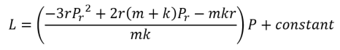

In the form . Hence, this linearised form can be substituted as the test function for stability analysis.

## Range of stability for Euler Explicit

Substituting

For stability,

Since

The stability expression is given by:

As the h value obtained from section 4.3 is performed using a linearized function, there is a need to verify it against the actual output of the numerical scheme. The Euler Explicit program is ran using the calculated h value and compared against outputs using other h values in the vicinity of the calculated version. Table 4 and Table 5 provides the information on the parameters and values used in the comparison process.

Table : Summary of parameters and their acronyms for Euler Explicit

|  |  |
| --- | --- |
| **Acronym** | **Parameter** |
| r | Growth Rate |
| m | Minimum threshold |
| k | Population capacity |
| N | Fishing licenses |
| P | Population |
|  | Linearized coefficient of P |
| C.hEE | Calculated critical time-step, h for Euler Explicit |
| E.hEE | Empirical critical time-step, h for Euler Explicit |
| δ | Difference between |(E.hEE - C.hEE)|/ C.hEE |

Table : Summary of trial values used for each parameter

|  |  |  |  |  |  |  |
| --- | --- | --- | --- | --- | --- | --- |
| **Parameter** | **Trial 1** | **Trial 2** | **Trial 3** | **Trial 4** | **Trial 5** | **Trial 6** |
| r | 3 | 3 | 3 | 2 | 2 | 2 |
| k | 55 | 38 | 65 | 55 | 40 | 65 |
| m | 10 | 13 | 8 | 10 | 10 | 8 |
| N | 10 | 10 | 10 | 10 | 10 | 10 |
|  | -11.82 | -2.41 | -20.01 | -7.28 | -3.22 | -12.89 |

Table Calculated and empirical hcritical for various trial cases of r, m, k, N for Euler Explicit

|  |  |  |  |  |  |  |
| --- | --- | --- | --- | --- | --- | --- |
| **Parameter** | **Trial 1** | **Trial 2** | **Trial 3** | **Trial 4** | **Trial 5** | **Trial 6** |
| C.hEE | 0.169 | 1.204 | 0.0998 | 0.275 | 0.621 | 0.155 |
| E.hEE | 0.28 | 1.28 | 0.17 | 0.44 | 0.97 | 0.24 |
| δ | 65.68% | 6.31% | 70.34% | 60.00% | 56.20% | 54.84% |

Table 6 shows that the calculated hcritical is always lower than the empirical hcritical. The difference ranges from 55% to 70%, with an outlier of 6.3%. This shows that the calculated hcritical value is actually a conservative estimate of the empirical hcritical, and thus can be confidently used as a guide for the maximum time step when applied with Euler Explicit method.

For some values of r, m, k, N, such as in trial 1, the calculated hcritical gives a good solution in which the solution starts to converge to an asymptote. However, this is not always the case as seen in trial 2, whereby the h value which the solution converges is h = 0.8, while the calculated hcritical is 1.20, as shown in Figure 24.

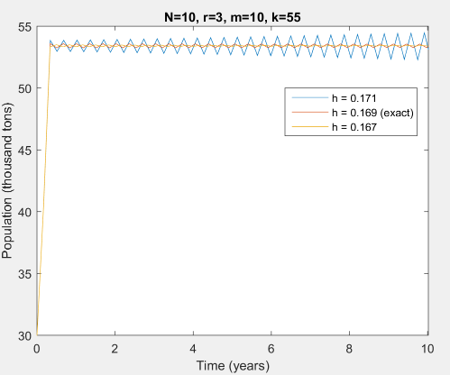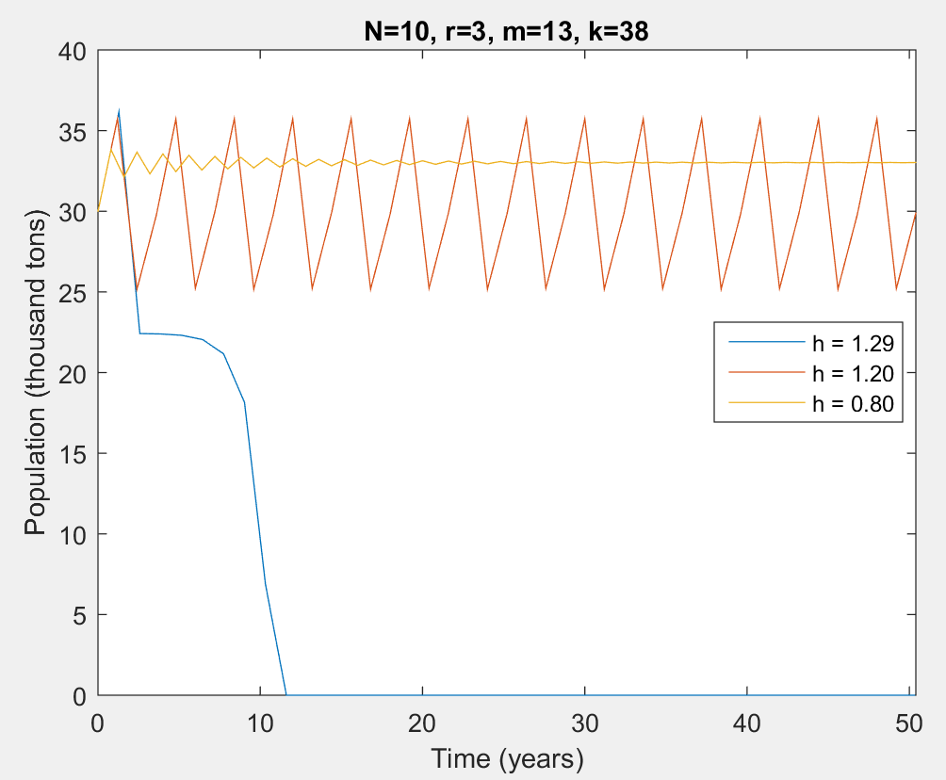

Figure : Solutions at various h values for Trial 1 (left) and Trial 2 (right)

## Range of stability for Trapezoidal method

As described in section 3.3, Trapezoid Method is an implicit method and it is unconditionally stable for any value of h. Thus, the selection of h value is based purely on accuracy. The stability analysis is as follows:

Substituting and

For stability,

Since h > 0, and < 0 for the solution to be bounded, h is always less than 0 and the Trapezoid method is unconditionally stable.

Since h is always positive, and must be negative for the solution to be bounded, h is always negative and the Trapezoid method is unconditionally stable as shown in Figure 25. Figure 26 illustrates stability is achieved even at h = 3.

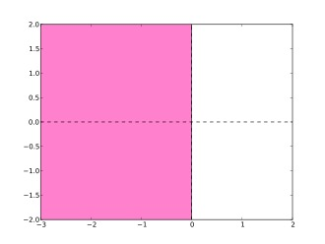

Figure : Stability plot (Complex Plane) of Trapezoidal method

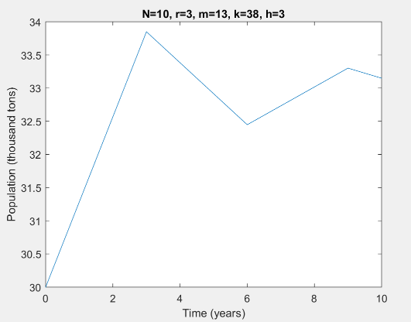

Figure : Trapezoid method showing stability even at h = 3

## Range of stability for Modified Trapezoidal method

Substitute

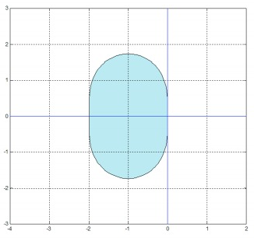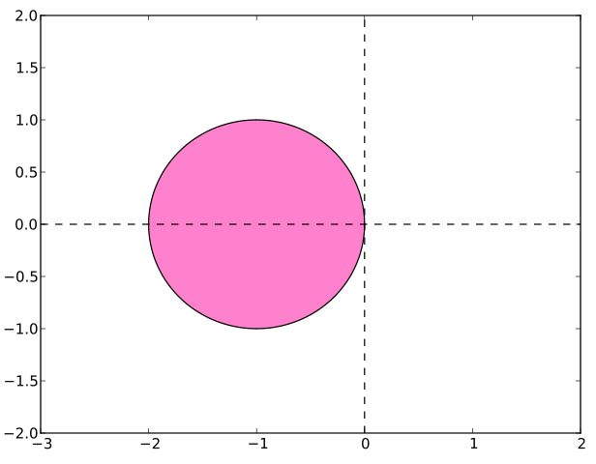

Figure : Stability plot (Complex Plane) of Modified Trapezoid Method (left) and Euler Explicit (right)

Interestingly, even though the stability expression for the Modified Trapezoid method is different from that of Euler Explicit, the result hcritical value is exactly the same (C.hEE in Table 6 and C.hMT in Table 8), given by if is a real number. This is because the stability plot of Modified Trapezoid Method crosses the real axis at -2, and hcritical scales the value of along the real axis (and imaginary axis if is complex). The difference between Euler Explicit and Modified Trapezoid method is that the latter has a larger stability area in the complex region compared to former as shown in Figure 27.

Table 5 and Table 7 provides the information on the parameters and values used in the comparison process. Table 8 shows that the calculated hcritical is always lower than the empirical hcritical. The difference ranges from 25% to 30%, with two outliers of 154.5% and 352%. This shows that the calculated hcritical value is actually a conservative estimate of the empirical hcritical, and thus can be used confidently as a guide for the maximum time step when applied with Modified Trapezoid method.

Table : Summary of parameters and their acronyms for Modified Trapezoidal method

|  |  |
| --- | --- |
| **Acronym** | **Parameter** |
| r | Growth Rate |
| m | Minimum threshold |
| k | Population capacity |
| N | Fishing licenses |
| P | Population |
|  | Linearized coefficient of P |
| C.hMT | Calculated critical time-step, h for Modified Trapezoidal method |
| E.hMT | Empirical critical time-step, h for Modified Trapezoidal method |
| δ | Difference between |(E.hMT - C.hMT)|/ C.hMT |

Table : Calculated and empirical hcritical for various trial cases of r, m, k, N for Modified Trapezoid method

|  |  |  |  |  |  |  |
| --- | --- | --- | --- | --- | --- | --- |
| **Parameter** | **Trial 1** | **Trial 2** | **Trial 3** | **Trial 4** | **Trial 5** | **Trial 6** |
| C.hMT | 0.169 | 1.204 | 0.0998 | 0.275 | 0.621 | 0.155 |
| E.hMT | 0.239 | 1.1743 | 0.141 | 0.389 | 0.879 | 0.219 |
| δ | 29.71% | 24.33% | 27.66% | 154.50% | 26.28% | 352.05% |

With reference to Figure 28, stability range of h is approximately ≤1.

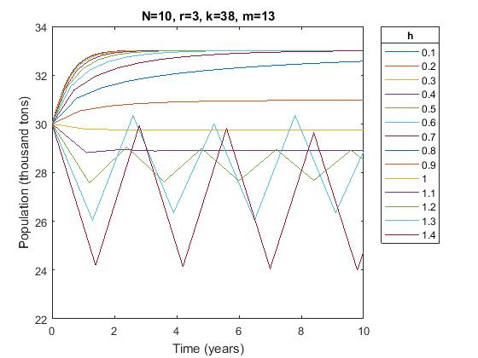

Figure : Graph of population of values of h (0.1 to 1.4) for Modified Trapezoidal method

## Range of stability for RK4

Stability plot of RK4 crosses the real axis at -2.81 in Figure 29. Since hcritical serves as a scaling factor along the real axis (and imaginary axis if is complex), hcritical can be determined by .

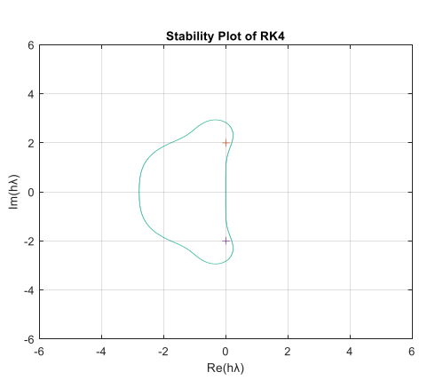

Figure : Stability plot (Complex Plane) of RK4

Table 5 and Table 9 provides the information on the parameters and values used in the comparison process. Table 10 shows that the calculated hcritical is always lower than the empirical hcritical. The difference ranges from 48% to 51%, which is the smallest difference range as compared to the other three methods. This shows that the calculated hcritical value is actually a conservative estimate of the empirical hcritical, and thus can be used confidently as a guide for the maximum time step when applied with RK4 method.

Table : Summary of parameters and their acronyms for RK4

|  |  |
| --- | --- |
| **Acronym** | **Parameter** |
| r | Growth Rate |
| m | Minimum threshold |
| k | Population capacity |
| N | Fishing licenses |
| P | Population |
|  | Linearized coefficient of P |
| C.hRK4 | Calculated critical time-step, h for RK4 method |
| E.hRK4 | Empirical critical time-step, h for RK4 method |
| δ | Difference between |(E.hRK4 - C.hRK4)|/ C.hRK4 |

Table : Calculated and empirical hcritical for various trial cases of r, m, k, N for RK4

|  |  |  |  |  |  |  |
| --- | --- | --- | --- | --- | --- | --- |
| **Parameter** | **Trial 1** | **Trial 2** | **Trial 3** | **Trial 4** | **Trial 5** | **Trial 6** |
| C.hRK4 | 0.238 | 1.166 | 0.140 | 0.386 | 0.873 | 0.218 |
| E.h RK4 | 0.36 | 1.72 | 0.21 | 0.58 | 1.30 | 0.33 |
| δ | 51.43% | 47.52% | 49.54% | 50.26% | 48.97% | 51.38% |

Figure 30 shows that for stability to be satisfied, h should be ≤ 1.

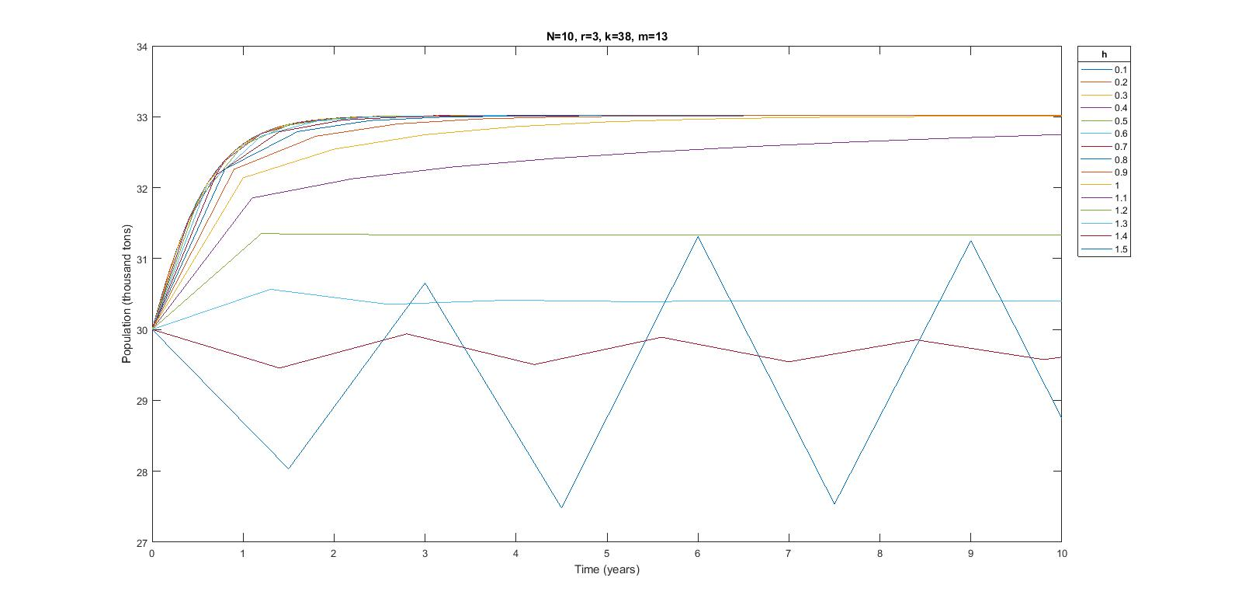

Figure : Graph of population of values of h (0.1 to 1.5) for RK4

## Summary of Stability

Table 11 shows a summary of the calculated, empirical hcritical and convergent h for the four numerical methods discussed previously. Convergent h is defined as the time-step, h, for which the solution no longer exhibits any oscillation, characterized by no overshoot as the solution tends towards the asymptote. Convergent h provides an indication of the time-step which the solution starts to become accurate. Table 11 illustrates a few important points:

1. The calculated hcritical value is always smaller than the empirical hcritical value, hence, it is considered as a conservative estimate of the empirical hcritical and can be trusted as a method to choose a h value that will ensure stability.
2. Stability does not necessarily mean accuracy, and the convergent h values shows that it depends on the order of accuracy of the method. Euler Explicit is a first order method, and its convergent h is 38% of the calculated hcritical. Modified Trapezoid method is a second order method, and its convergent h is 80% of the calculated hcritical. RK4 is a fourth order method, and its convergent h is 97% of the calculated hcritical. While there is no formula to calculate the convergent h exactly, the order of method serves as a guide for an initial estimate of its value.
3. RK4 and Trapezoidal method both has very similar convergent h value, suggesting that for this problem their accuracy might be quite close.

Table : Summary table of calculated, empirical hcritical and convergent h for 4 numerical methods

|  |  |  |  |  |
| --- | --- | --- | --- | --- |
|  | EE | Trap-NR | Trap-Mod | RK4 |
| Calculated hcritical | 1.204 | 1.204 | - | 1.166 |
| Empirical hcritical | 1.28 | 1.46 | - | 1.72 |
| Convergent h | 0.46 | 0.97 | 1.26 | 1.20 |

# Accuracy Analysis

Accuracy reflects the ability of the numerical scheme to tend towards an exact value with a given time-step duration. To review the accuracy between the different methods, a set of varying time-step durations were implemented for a set of r, k, m, N values for each of the four numerical methods.

In addition, due to the non-linear and non-homogenous nature of the population model, no analytical solution can be obtained by the separation of variables. Therefore, an exact value is obtained at the t=1-year step using a small time-step duration with the RK4 numerical method as it has the highest order of accuracy. The population tends to 32,618 tons after a year as shown in Table 12 and this estimated value is used for comparison of accuracy analysis between numerical methods.

From the Figure 31 shown below, it can be seen that for time step duration of 1 year, the accuracy can be attained best by the implicit Trap-NR method, followed by RK4, EE, and lastly Trap-Mod. This deviates slightly from the understanding that the accuracy is highest in the following arrangement RK4, followed by Trap-Mod and Trap-NR and lastly EE, as the order of accuracies are to the order of four, two and one respectively. The reason for this is possibly because of the region of stability that is required for the explicit methods. This means that the explicit method may not have been in the stable region when the time-step duration is set at h=1 year, which is coherent to what was discussed in the earlier sections.

In this report, a time-step duration of 0.1 have been generally used for trending analysis as it allows the explicit methods to attain stability even at the first time-step. It is thus recognized that 0.1 is able to provide a stable analysis for all the explicit numerical schemes. Hence, when the accuracy observation is made at the time-step duration of h=0.1 year, it is safe to extract the relationship between the various methods. The accuracy is shown to be attained best by RK4, followed by Trap-NR, Trap-Mod and lastly EE. At time step durations h smaller than 0.1, it can be seen that this relationship is coherent.

Table : Population (after 1 year) vs Time-step for the four numerical methods



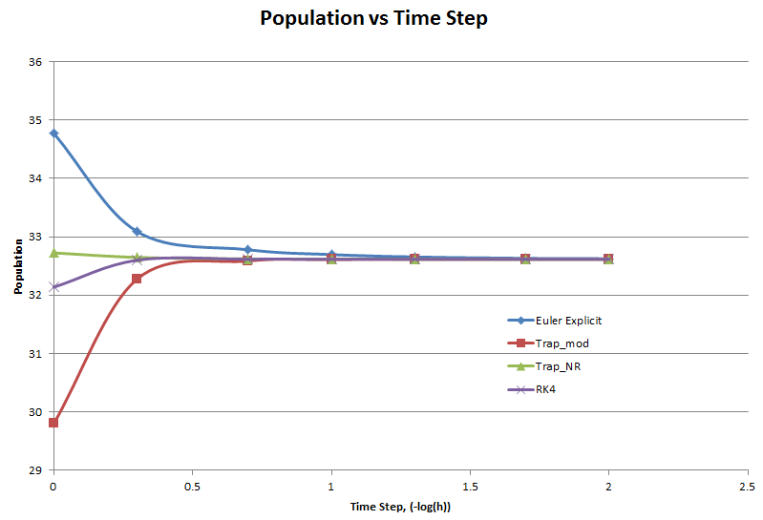

Figure : Population (after 1 year) vs Time-step for the four numerical methods

# Conclusion

To achieve a population of , the proposed number of fishing licenses to be issued for the next 10 years is 10. This value is estimated through the application of RK4 method as it yields the most stable and accurate solution, as compared to the other numerical methods evaluated.

# References

Alam, S. (2016, January 28). *121 oil pollution cases reported between 2009 and 2015*. Retrieved October 3, 2017, from The Rakyat Post: http://www.therakyatpost.com/news/2016/01/18/oil-spill-poses-threat-to-malaysian-marine-environment/

Al-Odaini, N., & Zakaria, M. (2006). Management of Pharmaceutical Compounds in Environment: Occurrence, Sources, Impacts and Control. Kuala Lumpur. Retrieved from https://www.researchgate.net/publication/255699852_Management_of_Pharmaceutical_Compounds_in_Environment_Occurrence_Sources_Impacts_and_Control

Al-Odaini, N., Pauzi Zakaria, M., Ismail Yaziz, M., & Surif, S. (2011). Detecting Human Pharmaceutical Pollutants in Malaysian Aquatic Environment: A new challenge for water quality management. In *Contemporary environmental quality management in Malaysia and selected countries.* UPM Press. Retrieved from https://www.researchgate.net/publication/279913351_Detecting_Human_Pharmaceutical_Pollutants_in_Malaysian_Aquatic_Environment_A_new_challenge_for_water_quality_management

BioExpedition. (2012, April 13). *Stingray Facts and Information*. Retrieved October 3, 2017, from BioExpedition: http://www.bioexpedition.com/stingray/

Food and Agriculture Organisation of the United Nations (FAO). (2016). *The State of World Fisheries and Aquaculture.* Retrieved from http://www.fao.org/3/a-i5555e.pdf

Idris, M. (2017, June 7). *Seeking a more sustainable future for our oceans*. Retrieved October 3, 2017, from Free Malaysia Today: http://www.freemalaysiatoday.com/category/opinion/2017/06/07/seeking-a-more-sustainable-future-for-our-oceans/

Mobilik, J., & Hassan, R. (2016). Marine Pollution Threat from Shipping Activity towards Ocean Sustainability. Malaysia. Retrieved from https://www.researchgate.net/publication/311637494_Marine_Pollution_Threat_from_Shipping_Activity_towards_Ocean_Sustainability

National Geographic. (2010, April 27). *Sea Temperature Rise*. Retrieved October 3, 2017, from National Geographic: http://www.nationalgeographic.com/environment/oceans/critical-issues-sea-temperature-rise/

Spells, K. (n.d.). *Environmental Factors*. Retrieved October 3, 2017, from Stingrays: http://kobespells.weebly.com/regulation.html

The Straits Times. (2016, May 14). Malaysia's turtles dying due to demand for stingray.

World Wide Fund for Nature (WWF). (2016). *Singapore Seafood Guide.* Retrieved from http://d2ouvy59p0dg6k.cloudfront.net/downloads/wwf_seafoodguide2016.pdf

# Appendix

This section contains the Matlab subroutines for numerical methods.

## General

%Define population dynamic equation

function [ Pdot ] = Pdot( P, N, r, k, m )

Pdot = -r*P*(1-P/k)*(1-P/m)-2*N;

end

## Euler Explicit method (Subroutine)

%Euler Explicit method

clear all

% define parameters and initial values

P0 = 30; %initial population

N = 10; %number of licenses

r = 3; %growth rate

k = 38; %population capacity

m = 13; %threshold population

h = 0.46; %time-step size

n = 10; %total number of years

steps = ceil(n/h);

n = steps*h;

T = 0:h:n;

P = zeros(1+steps,1);

P(1) = P0;

% Euler Explicit Forward Method

for i = 1:steps

P(i+1) = P(i) + h*Pdot(P(i),N,r,k,m);

if P(i+1)<0

P(i+1) = 0;

end

end

plot(T,P);

hold on;

title(['N=',num2str(N),', r=',num2str(r),', m=',num2str(m),', k=',num2str(k),', h=',num2str(h)]);

xlabel('Time (years)');

ylabel('Population (thousand tons)');

xlim([0 n]);

## Trapezoidal method (Subroutine)

%Trapezoidal method

close all

clear all

tol=0.01;

r=3;

m=13;

k=38;

N=10;

h=1.26;

n=10; %total number of years

steps = ceil(n/h);

n = steps*h;

T=0:h:n;

P=zeros(steps+1,1);

P(1)=30;

for i=1:steps

Yt1=P(i)+h*Pdot(P(i),N,r,k,m); % assume an initial value

eps=1;

while eps>tol

%form a function

Fx=Yt1-P(i)-h/2*(Pdot(Yt1,N,r,k,m)+Pdot(P(i),N,r,k,m));

%1st-order derivative depends on f

dFx=1-h/2*(-r+2*r*Yt1/m+2*r*Yt1/k-3*r*Yt1^2/k/m);

% define a new x

Yt2=Yt1-Fx/dFx;

eps=abs(Yt2-Yt1); % decide when to abort

Yt1=Yt2;

end

P(i+1)=P(i)+h*1/2*(Pdot(P(i),N,r,k,m)+Pdot(Yt1,N,r,k,m));

if P(i+1)<0

P(i+1)=0;

end

end

plot(T,P);

title(['N=',num2str(N),', r=',num2str(r),', m=',num2str(m),', k=',num2str(k),', h=',num2str(h)]);

xlabel('Time (years)');

ylabel('Population (thousand tons)');

xlim([0 10]);

## Modified Trapezoidal method (Subroutine)

%Modified Trapezoidal method

close all

clear all

r=3;

m=13;

k=38;

N=10;

h=0.97;

n=10; %total number of years

steps = ceil(n/h);

n = steps*h;

T=0:h:n;

P=zeros(steps+1,1);

P(1)=30;

for i=1:steps

Yt=P(i)+h*Pdot(P(i),N,r,k,m);

P(i+1)=P(i)+h*0.5*(Pdot(P(i),N,r,k,m)+Pdot(Yt,N,r,k,m));

if P(i+1)<0

P(i+1)=0;

end

end

plot(T,P);

title(['N=',num2str(N),', r=',num2str(r),', m=',num2str(m),', k=',num2str(k),', h=',num2str(h)]);

xlabel('Time (years)');

ylabel('Population (thousand tons)');

xlim([0 n]);

## RK4 method (Subroutine)

%RK4

close all

clear all

P0=30;

r=3;

m=13;

k=38;

N=10;

%h=0.1;

%n=10; %total number of years

for h = 0.22:0.01:0.25 %CHANGE THE RANGE OF H HERE

n = 10;

steps = ceil(n/h);

n = steps*h;

T = 0:h:n;

P = zeros(1+steps,1);

P(1) = P0;

for i=1:steps

P1=h*Pdot(P(i),N,r,k,m);

P2=h*(Pdot(P(i)+(P1/2),N,r,k,m));

P3=h*(Pdot(P(i)+(P2/2),N,r,k,m));

P4=h*(Pdot(P(i)+(P3),N,r,k,m));

P(i+1)=P(i)+(P1+2*P2+2*P3+P4)/6;

if P(i+1)<0

P(i+1)=0;

end

end

plot(T,P,'DisplayName',num2str(h));

hold on

end

title(['N=',num2str(N),', r=',num2str(r),', k=',num2str(k),', m=',num2str(m)]);

xlabel('Time (years)');

ylabel('Population (thousand tons)');

xlim([0 10]);

lgd = legend('show','Location','bestoutside');

title(lgd,'h')